|  |
| --- |
| Photo displaying partial image of two pie charts on a canvas-textured page |
| ASSIGNMENT 2 - VISUALIZATION |
| |  |  |  | | --- | --- | --- | |  |  |  | |

Table of Contents

Introduction 2

Tool Justification 2

Data Analysis 2

Report Finding 3

Year wise Comparison 3

Comparison based on Incidents 3

Comparison based on people cleared 3

Comparison based on people charged 3

Top 3 Cities 4

Ontario 4

Quebec 4

Manitoba 5

Correlation 6

Crime rate Prediction 6

Ontario 6

Incident 6

Rate 7

Cleared 7

Quebec 7

Incident 7

Rate 8

Cleared 8

Manitoba 8

Incident 8

Rate 8

Cleared 9

Conclusion 9

# Introduction

As part of project which was given by RCMP (Federal Police) the aim was to understand the different crimes that happen across Canada. RCMP wanted to gain understanding based on the data available on how to better work and support the police. RCMP primarily operates in 3 different provinces namely – Ontario, Quebec, and Manitoba. Violations are broadly categorized into 2 categories Criminal code violations and Federal Statute Violations. Under criminal code violations some of the crimes are sexual assaults, homicide, robbery, murder to name a few. Similarly, crimes under Federal Statute Violation include drug violation, property, arson to name a few.

# Tool Justification

Power BI has a number of reasons because of which it can be used for visualization and data analysis which are as stated below:

* Interactive visualizations and easy integration with MS tools.
* Power BI gives access to reports and dashboards for data analysis.
* Access on-premises as well through cloud.
* Secure sharing of reports and data analysis – ease of sharing and collaborating on the reports.
* Data modelling capabilities for complex reports and dashboards.
* Connection to multiple data sources -can connect with 60+ popular solutions that nowadays companies often use e.g. Spark, Hadoop, SAP. Power BI is compatible with operating systems – Windows, iOS and Android.
* Can handle large sets of data and compute quickly.
* Has some inbuilt ETL capabilities.
* Drag and drop facility for users to create charts, reports and dashboards. Power users can also use this tool for data analysis.

# Data Analysis

As mentioned, the level of data is very extensive so gain better understanding and derive meaningful insights only Manslaughter is considered for this report. The idea being using only manslaughter is to understand the severity of this crime and then figure out if specific patters of areas need to be concentrated on to try and avoid these situations.

There are multiple columns in the dataset bit for the analysis and reporting the datapoints used are reference date (year), geo - city name along with the province or province data, violations - manslaughter, statistics - total incidents, adults charged, persons charged, young charged, value – this provides information in form of number, percentage.

As part of data processing a couple of columns were added for better visualization a flag to identify a province, classification of whether it’s a city or province or non-city to avoid data doubling and get correct results. Instead of having long name only the city or non-city name to show in the reports.

# Report Finding

## Year wise Comparison

### Comparison based on Incidents

As observed in the graph below Ontario has the highest incidents over the years in case of manslaughter. In Queue the numbers are more or less in the range of 5-9 and is much less as compared to the other two provinces. In case of Manitoba till 2015 the number of incidents were less but they have been increasing since then. Major jump was observed from 2015 to 2016 wherein the number has almost doubled. Conversely the number reduced by the same amount from 2016 to 2017 in Manitoba. All 3 provinces have reported the highest numbers ever in 2020.

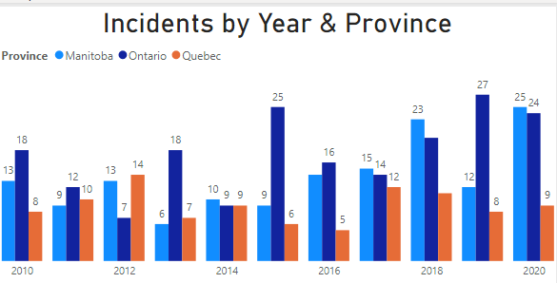

### Comparison based on people cleared

Though the number of incidents and people cleared look the same there is slight difference between the two. This difference is more or less in the range of 0-2 for each of the provinces.

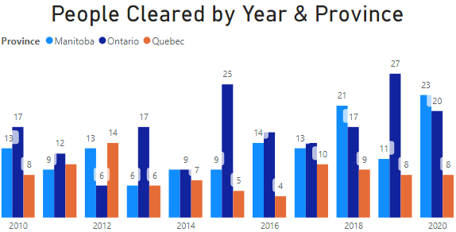

### Comparison based on people charged

If you compare charges between the adults and youth, the number of youths being charged are much less as compared to adults. In case of Ontario and Manitoba ratio of adults charged are almost double as compared to youth. In Queue the charges against the youth is almost non – existent.

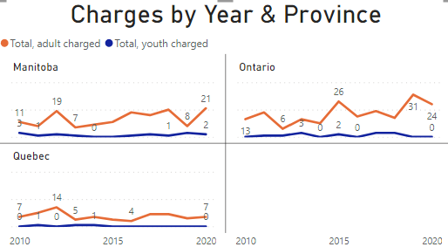

## Top 3 Cities

### Ontario

Consistently over years and cumulative over the years the same 3 cities have reported higher incidents. In case of Ontario, Toronto has the highest number of incidents. Though the range over the years for Toronto lies between 3-5.

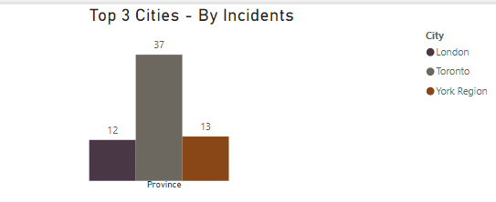

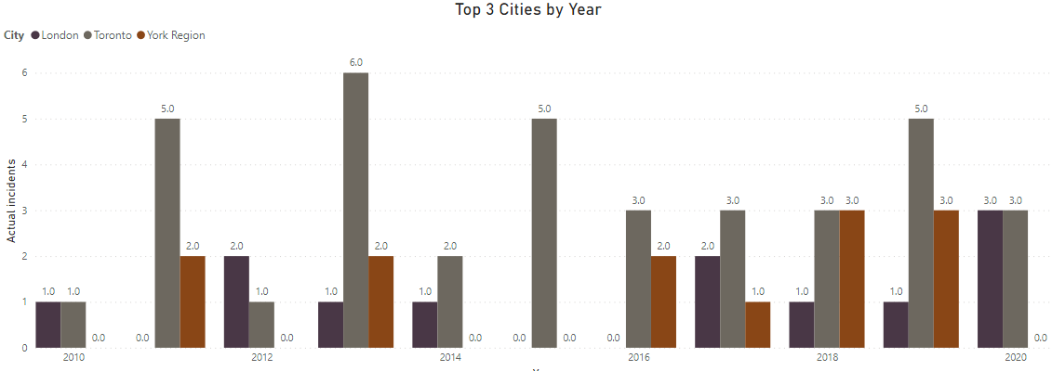

### Quebec

Consistently over years and cumulative over the years the same 5 cities have reported higher incidents.3 of them have similar numbers these being Saint-Jean-sur-Richelieu, Kativik Region and Laval. In case of Quebec, Montreal has the highest number of incidents. Over the years, Montreal has almost same numbers in 2013,2014 and 2017.

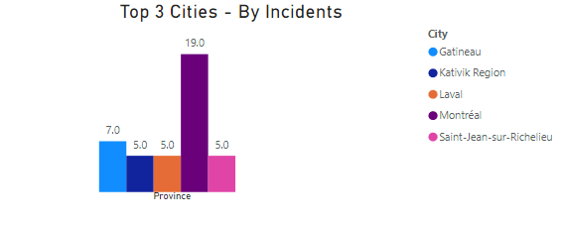

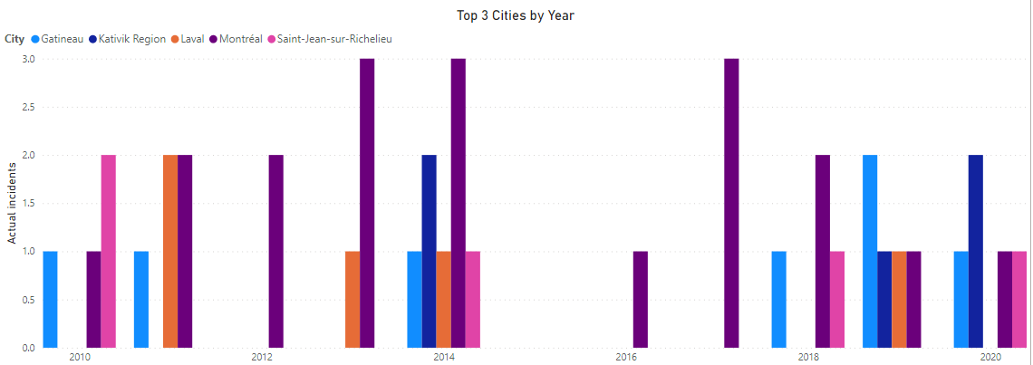

### Manitoba

Consistently over years and cumulative over the years the same 3 cities have reported higher incidents. In case of Manitoba, Winnipeg has the highest number of incidents. The numbers in Winnipeg is almost 3-5 times as compared to the other two cities over the years. In case of cumulative amounts its it 7-9 times higher than the other 2 cities.

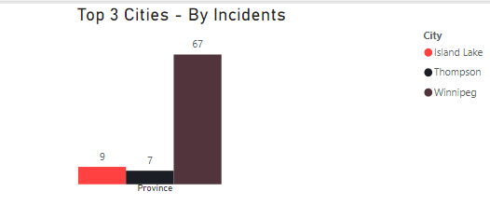

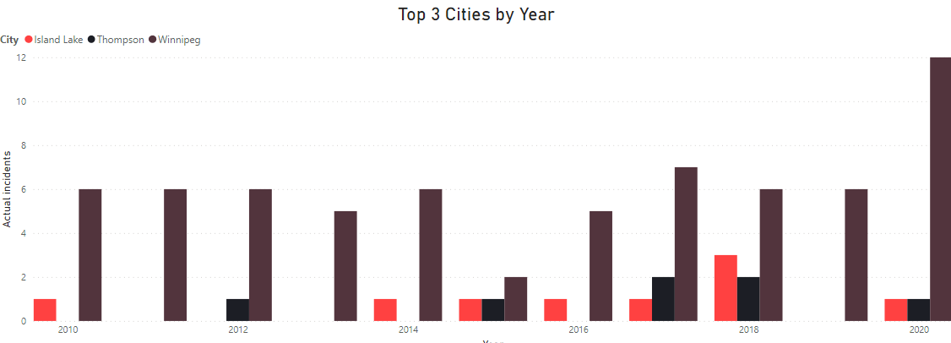

## Correlation

In this correlation co-efficient was calculated to see if there is a relation between the adults charged and youths that were charged. The graph depicts there is a strong co-relation in the cities of Mirabel followed by Montreal and Toronto. The remaining cities relation is less than 50%. Some of the cities also have a negative co relation

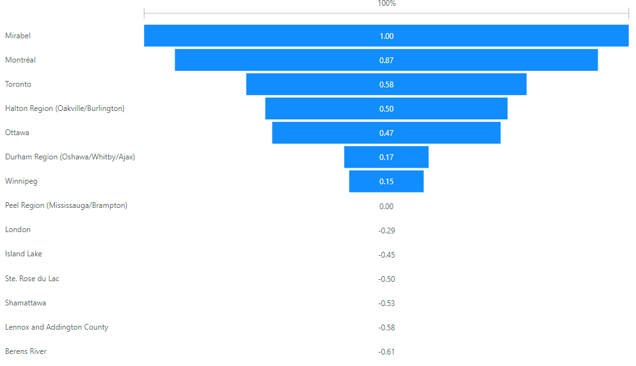

# Crime rate Prediction

Comparing all the 3 provinces the prediction for the next year is less as compared to the latest year for which data is available. Forecasting is done for the number of incidents, rate and total people that have been cleared. There is no major drop for any of the provinces in terms of the 3 paramters.

## Ontario

### Incident

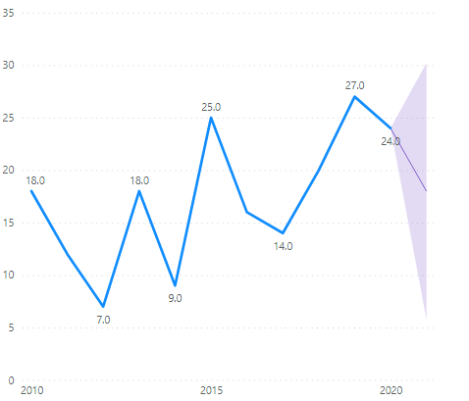

### Rate

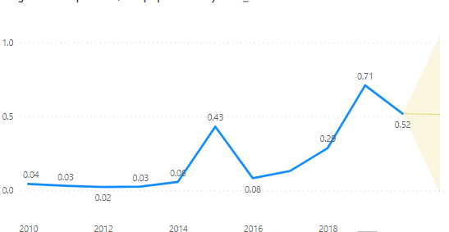

### Cleared

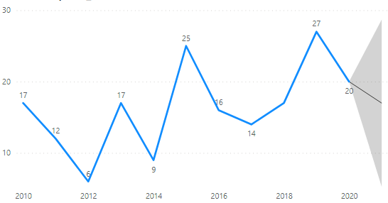

## Quebec

### Incident

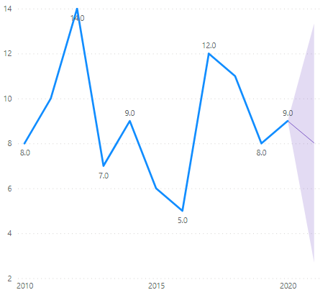

### Rate

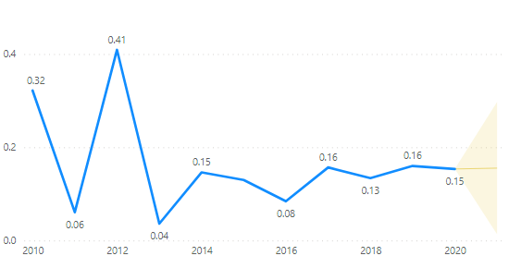

### Cleared

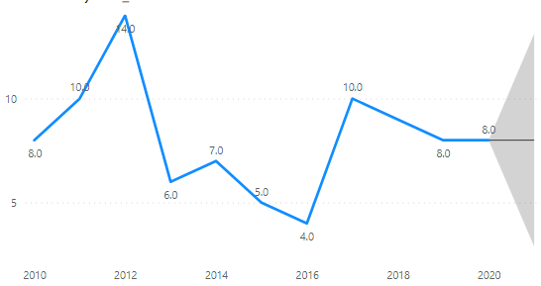

## Manitoba

### Incident

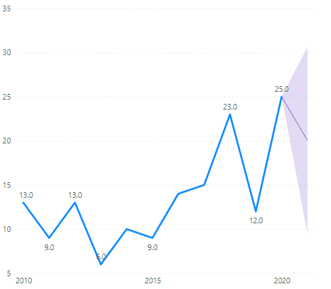

### Rate

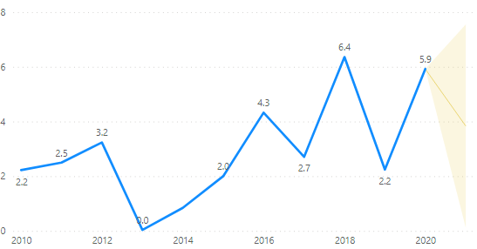

### Cleared

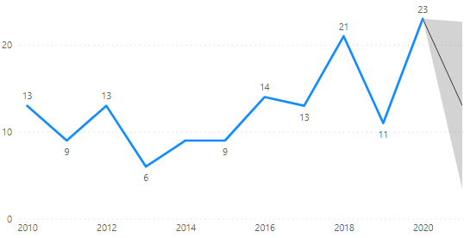

# Conclusion

In conclusion the numbers of cases are expected to reducing in the next year though the numbers are not very significant. Ontario has the highest incidents over the years in case of manslaughter followed closely by Manitoba whereas Quebec doesn’t have significant numbers. RCMP has to focus more on Ontario and Manitoba. The major metropolitan cities have to be monitored closely as the crime rates are higher in these areas. Special attention has to be given to adults are they are tried more than youth.